Name ____________________________________________Date _________________
Ratios and Proportions/Rates/6.RP.2 Lesson 8 –Homework
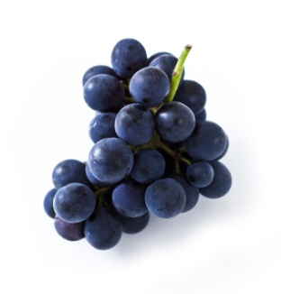
Write each real-world example as a rate using labels. Then find the unit rate.

1) Isabella spends $20 for 4 pounds of grapes.

2) Mrs. Thomas charges $60 for 120 minutes of tutoring.

3) Melissa types 1300 words in 13 minutes.

4) Maddy put 72 chairs in 4 rows.

In questions #5-6, determine which unit rate is greater.

5) Paul drove 600 miles in 10 hours and Mary drove 700 miles in 20 hours
Paul | Mary

Lily | Robby
- Lily reads 12 pages in 36 minutes and Robby reads 22 pages in 44 minutes.

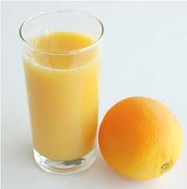
In questions #7, determine which unit rate is greater. Make your own table!

- Tropicana charges $8 for 2 ounces of orange juice. Minute Maid charges $12 for 4 ounces of orange juice.

- Holly needs to buy some fabric. She can buy 6 yards for $16.26 or 5 yards for $13.85.
$13.85
$16.26
5 yards
6 yards
$1.20

a) Find the unit price for the 6 yards of fabric.

b) Find the unit price for the 5 yards of fabric.

c) Which size fabric is the best value? Explain your answer.

