Inequalities Guided Notes

An inequality says that two values are not equal.

a ___ b means that a is less than b
a ___ b means that a is greater than b

a____ b means that a is less than or equal to b
a ____b means that a is greater than or equal to b

Ex 1: Which answers from the set make the inequality true?
v > 9
{3, 6, 7, 9, 12}

Ex 2: Which answers from the set make the inequality true?
x ≤ 9
{5, 9, 11}

Inequalities can be represented on a _____________ ______________.
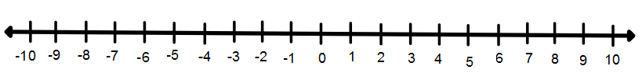
a > 3

When shading on a number line remember that as you go to the ______________ a number line gets larger. When you go to the _______________ a number line gets smaller.

Less than < -- shade to the __________
Greater than > -- shade to the _________

If the inequality sign is < or > then you put an __________ __________ on the number line because the number is not part of the solution so it cannot be shaded.

> , < ___________ circle

If the inequality sign is ≥ or $≤$ then you put a ___________ ____________ on the number line because the number is part of the solution so it is shaded.

≤ , ≥ ___________ circle

Ex. 3: Represent the inequality on a number line.
c ≤ 5

Practice
Represent each inequality on a number line.
- z > 0

- r ≥ - 5

- y ≤ 8

- b < - 4

Ex.4: Heather needs to raise $5000 to go on a mission trip. She has earned $2000 so far. Write an inequality for the amount of money, m, she still needs to raise. Represent the inequality on a number line.

Ex. 5: Adam spent less than $500 on rent last month. Write an inequality to represent this amount. Graph the inequality on a number line.

