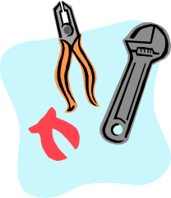

CRITICAL THINKING QUOTE RESPONSE EDITING CHECKLIST

CAPITALIZATION Writer Peer
- beginning of sentences
- proper nouns (Places, Names)
- important words in a title
- I

PUNCTUATION
- end marks for every sentence
- quotation marks around dialogue
- commas in a series
- commas with quotations
- separated city, state and country w commas

SPELLING
- circle words unsure of
- check for correct there, their, they’re
check for correct to, too, two
- abbreviated ELA correctly
WRITER
- used complete sentences
- wrote class heading (upper left/above image)
- includes a brief bio of the author
- explained the quote in own words
- did NOT center text
- used quote/part of quote from text
- answered all parts of the question ______ _______

Read softly out loud, watching for errors. Don’t skim over errors.

