Remembering Nelson Mandela – Lesson Plan
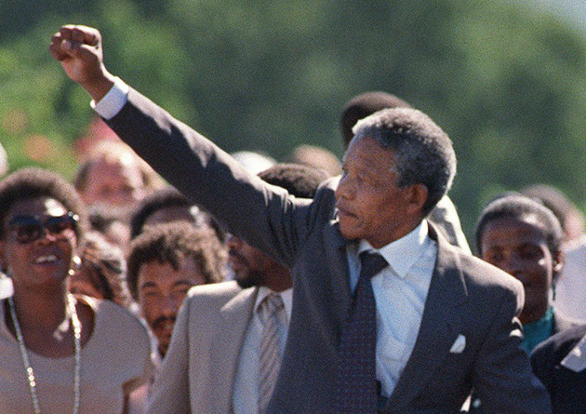

Introduction
In this lesson plan, students will use text from Mandela’s autobiography “Long Walk to Freedom” to connect with Mandela’s life and words.

Subjects
News and current events, world, social issues.

Estimated Time
One class period

Materials
-Excerpt from “Long Walk to Freedom”

Grade Level
7th

Warm Up Activity
Watch the story of Nelson Mandela’s life from Former NewsHour senior correspondent Charlayne Hunter-Gault that reflects on Mandela’s life and the impact he had on South Africa and the world.

Main Activity
- Print out the selection of Mandela’s autobiography “Long Walk to Freedom” and give it to each student.
- Introduce the Word Bank. Have them find each word on the above passage, read the definition and then underline/highlight the word. Discuss difficult vocabulary/questions.
- Ask them to underline every instance of the words “free” or “freedom” as they read the passage
- Have them choose the one sentence with “free” or “freedom” in it that struck each student as the most meaningful.
- Ask all students to form a circle, and repeat out loud the sentence that most impressed them. Many will repeat the same one. The activity will have a choral sound.
- At the end, ask students to write just two sentences that summarize this selection from Mandela’s autobiography.

COMPRHENSIOIN CHECK RESPONSE - Write complete statements to respond to the 3 questions or scenarios below. Many responses require more than one sentence because you have to explain. Use words from the Word Bank to provide a thorough answer to each scenario or question.

- What is happening in the excerpt? Summarize the response in your own words.

- What effect does the repetition of the phrase “hunger for the freedom” add to the overall interpretation of the excerpt? Please explain thoroughly using specific details.

- Write a sentence that states the main idea (the most important piece of information the author wants you to know) (the big picture) Nelson Mandela’s Long Walk to Freedom Part 11 Freedom.

Excerpt Nelson Mandela Autobiography The Long Walk to Freedom Part 11 Freedom

I was not born with a hunger to be free. I was born free — free in every way that I could know. Free to run in the fields near my mother's hut, free to swim in the clear stream that ran through my village, free to roast mealies under the stars and ride the broad backs of slow-moving bulls. As long as I obeyed my father and abided by the customs of my tribe, I was not troubled by the laws of man or God.

It was only when I began to learn that my boyhood freedom was an illusion, when I discovered as a young man that my freedom had already been taken from me, that I began to hunger for it. At first, as a student, I wanted freedom only for myself, the transitory freedoms of being able to stay out at night, read what I pleased, and go where I chose. Later, as a young man in Johannesburg, I yearned for the basic and honorable freedoms of achieving my potential, of earning my keep, of marrying and having a family — the freedom not to be obstructed in a lawful life.

But then I slowly saw that not only was I not free, but my brothers and sisters were not free. I saw that it was not just my freedom that was curtailed, but the freedom of everyone who looked like I did. That is when I joined the African National Congress, and that is when the hunger for my own freedom became the greater hunger for the freedom of my people. It was this desire for the freedom of my people to live their lives with dignity and self-respect that animated my life, that transformed a frightened young man into a bold one, that drove a law-abiding attorney to become a criminal, that turned a family-loving husband into a man without a home, that forced a life-loving man to live like a monk. I am no more virtuous or self-sacrificing than the next man, but I found that I could not even enjoy the poor and limited freedoms I was allowed when I knew my people were not free. Freedom is indivisible; the chains on anyone of my people were the chains on all of them, the chains on all of my people were the chains on me.

It was during those long and lonely years that my hunger for the freedom of my own people became a hunger for the freedom of all people, white and black. I knew as well as I knew anything that the oppressor must be liberated just as surely as the oppressed. A man who takes away another man's freedom is a prisoner of hatred, he is locked behind the bars of prejudice and narrow-mindedness. I am not truly free if I am taking away someone else's freedom, just as surely as I am not free when my freedom is taken from me.

The oppressed and the oppressor alike are robbed of their humanity.

When I walked out of prison, that was my mission, to liberate the oppressed and the oppressor both. Some say that has now been achieved. But I know that that is not the case. The truth is that we are not yet free; we have merely achieved the freedom to be free, the right not to be oppressed. We have not taken the final step of our journey, but the first step on a longer and even more difficult road. For to be free is not merely to cast off one's chains, but to
live in a way that respects and enhances the freedom of others. The true test of our devotion to freedom is just beginning.

I have walked that long road to freedom. I have tried not to falter; I have made missteps along the way. But I have discovered the secret that after climbing a great hill, one only finds that there are many more hills to climb. I have taken a moment here to rest, to steal a view of the glorious
vista that surrounds me, to look back on the distance I have come. But I can rest only for a moment, for with freedom come responsibilities, and I dare not linger, for my long
walk is not yet ended.

WORD BANK
Find each word on the above passage. Read the definition and then underline/highlight the word.
- illusion - a misleading image presented as a visual stimulus.
- oppressor - An oppressor is any authority (a group or a person) that uses its power unjustly to keep people under control.
- transitory - of brief duration
- liberate – to give freedom
- obstruct - to prevent or get in the way of
- prejudice - preconceived opinion that is not based on reason or actual experience
- curtail - To cut short;
- humanity - refers to the human race
- transform - to change
- vista - a grand view
- virtuous - to behave in a good way/the right manner
- animated - big gestures
- indivisible - cannot be divided

COMPRHENSIOIN CHECK RESPONSE - Write complete statements to respond to the 3 questions or scenarios below. Many responses require more than one sentence because you have to explain. Use words from the Word Bank to provide a thorough answer to each scenario or question.

- What is happening in the excerpt? Summarize the response in your own words.

- What effect does the repetition of the phrase “hunger for the freedom” add to the overall interpretation of the excerpt? Please explain thoroughly using specific details.

- Write a sentence that states the main idea (the most important piece of information the author wants you to know) (the big picture) Nelson Mandela’s Long Walk to Freedom Part 11 Freedom.

