- Which of the following is an OBJECTIVE observation?
  - Chocolate ice cream is the best.
  - I think dogs are the most obedient pets.
  - The new iPhone app opens in less than a second.
  - That house they are building is so pretty.
- Which is NOT a step of the scientific method?
  - Develop a hypothesis c. Ask a question
  - Solve a problem d. Communicate results
- How do you read the volume of a graduated cylinder?
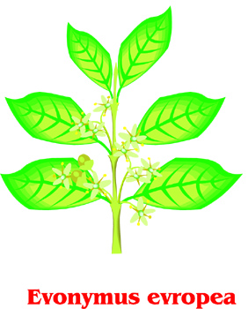
  - Below the meniscus c. Without the meniscus
  - Above the meniscus d. You don’t measure volume in a cylinder
- What is the first thing you should you do if you have an accident in the lab?
  - Clean it up c. Notify your teacher
  - See the nurse d. Don’t tell anyone
- Which of the following is an example of an inference about the plant pictured?
  - The plant has six leaves c. The plant has one stem
  - The plant has flowers d. The plant has roots
- Which is an observation about the plant pictured?
  - The plant is in acidic soil c. The plant’s flowers are used for reproduction
  - The plant is photosynthesizing d. The plant’s flowers attract hummingbirds
- 0.34 kilograms = grams
  - 34 grams c. 340 grams
  - 0.0034 grams d. 3400 grams
- 123 ml = L
  - 0.123 L c. 0.0123 L
  - 12,300 L d. 1.23 L
- 0.554 kg = _ mg
  - 554 mg c. 0.00554 mg
  - 554,000 mg d. 5.54 mg
- Length is measured in ____, Mass is measured in ____, and Volume is measured in ___.
  - Liters, Meters, Grams c. Grams, Liters, Meters
  - Meters, Grams, Liters d. Meters, Liters, Grams
- A Quantitative observation involves ___ while a Qualitative observation looks at ___.
  - Measuring; Characteristics c. Characteristics; Measuring
  - Linguistics; Quarries d. Quarries; Linguistics
- Which sentence best describes Theories and Laws?
  - A Theory is ALWAYS true while a Law can be changed.
  - A Law can only change if the Theory is tested numerous times.
  - A Law is ALWAYS true while a Theory can change.
  - A Theory is used to support a Hypothesis while a Law does not use a Hypothesis.

Two jars are placed on a counter with a McDonald’s French fry inside. One has a lid, the other does not. They are left alone to see which one decays faster. After two days, the fry in the closed jar looks fresher. Answer the questions that follow

- What is the independent variable?
  - The type of French fries c. The freshness of the French fries
  - Whether or not the jar has a lid d. The type of jars used
- What is the dependent variable?
  - The type of French fries c. The type of jars used
  - Whether or not the jar has a lid d. The freshness of the French fries
- What are the controls?
a. How long the fries are in the jar c. The freshness of the French fries
b. Whether or not the jar has a lid d. The type of jars, type of fries, when the fries were made
- What type of graph is shown on the right?
  - Line graph c. Pie chart/ circle graph
  - Double bar graph d. Bar graph
- What type of graph would best show changes over time?
  - Line graph c. Pie chart/ circle graph
  - Double bar graph d. Bar graph
- You wonder why your bike feels so slow when you’re out for a ride. You think that if you increase the air pressure in your tires, then your speed will increase. What is your next step? _____________________________________________________
- Why does my back ache after sleeping all night on my new fluffy mattress? What step in the scientific method have I just performed? _____________________________________________________________

Look at the picture to your right. Label the following as an observation (A), Inference (B) or Prediction (C)
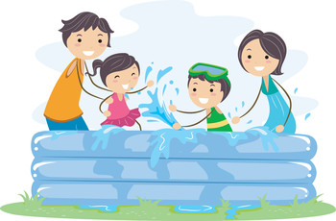
____ 20. The people in the pool are a family.
____ 21. There are four people in the pool.
____ 22. The water is warm.
____ 23. They will use towels to dry off.
____ 24. The boy is wearing a scuba mask.
____ 25. It is a sunny day.
____ 26. The girl is getting splashed with water.
____ 27. The swimming pool is made of plastic.
____ 28. They are in their back yard.
____ 29. The kids will be sunburned.
____ 30. The boy is wearing swim trunks.

