Name _____________________________________ Date ______________ Period___________
LAB SAFETY SCENARIOS WORKSHEET

Purpose: To apply your knowledge of safe lab practices to different scenarios.
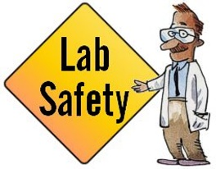
Directions: After reading each scenario description write:
- Write down which rule is being broken.
- Write down what the students should do.
SCENARIO DESCRIPTION | BROKEN RULE | RESPONSE
- Cindy broke a test tube. Carefully she picked up pieces with one hand and placed them in her other hand. Then she dumped the glass pieces into the wastebasket.

- Mike and Colleen had a lot of a chemical left from their investigation. They dumped the chemical in the sink and left the water running in the sink as they left class.

- Diana and Mike were going to be late to their next class. After rushing to put away a few materials, they left the rest of the materials on the lab table.
- The teacher was not in the room yet. Jake began weighing chemicals, touching them with his hands. His nose itched so he rubbed it.

- Heather and Jennifer were absent the day before when the investigation was discussed. They gathered the materials and watched their classmates to see what to do, not taking time to read the directions.
- Sam was heating a test tube. He didn’t put on safety goggles since he was wearing glasses. He slanted the tube away from his work area, but toward students on the opposite side of his lab table.
- Roberto didn’t pay attention when the teacher explained where safety equipment was found and how it was used. She thought to herself, “I’ll never need that.”
- Tony thought it would be really funny to dare his lab partner to put the cow eye lens in their mouth.

