Name ___________________________ Date ______________ Period __________________
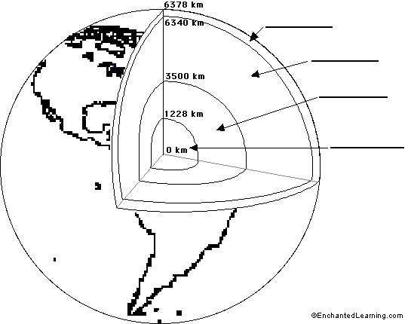

Layer:
Density:
Composition:
Temperature:
Additional fact:

Layer:
Density:
Composition:
Temperature:
Additional fact:

Layer:
Density:
Composition:
Temperature:
Additional fact:

Layer:
Density:
Composition:
Temperature:
Additional fact:

Topic Sentence:
Paragraph 1:

Paragraph 2:

Paragraph 3:

Paragraph 4:

Paragraph 5: Why have we not been able to explore the Earth’s layers by drilling through the crust? Cite evidence.

Concluding Sentence:

