Analyze a Photograph

Meet the photo.
What do you see?

Is the photo?

❑ ❑

Is there a caption?

❑ ❑

If so, what does the caption tell you?

Observe its parts.
Circle what you see in the photo.

What are the people doing in the photo?

What are the objects used for in the photo?

Write two words that describe the photo.

Try to make sense of it.
Who do you think took this photo?

Where do you think this photo was taken?

List something that helps you prove where it was taken.

Why do you think the photo was taken?

How does this photo compare to modern times?

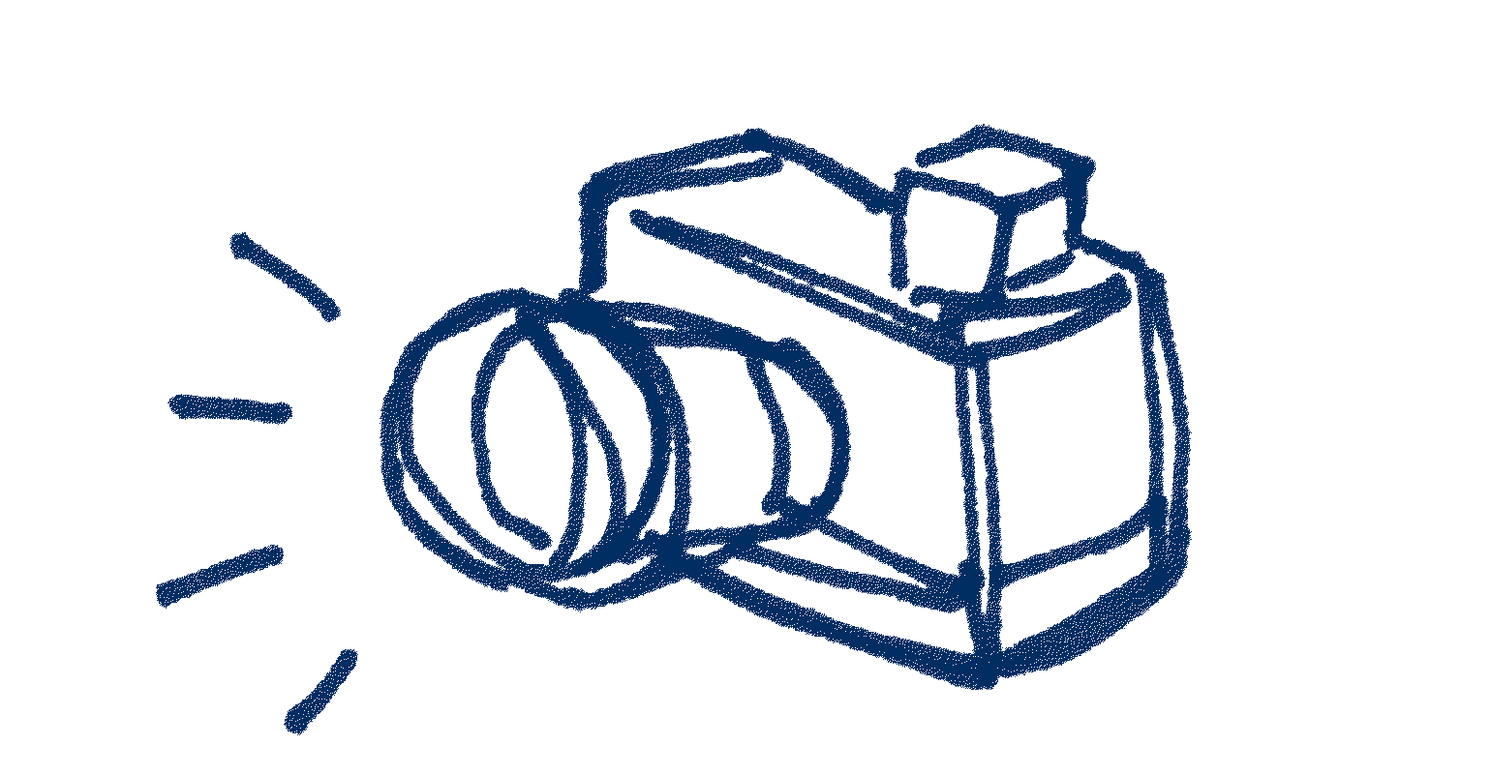

Use it as historical evidence.
Where do you think we could find out more information about the people or objects in the photo?

Materials created by the National Archives and Records Administration are in the public domain.

