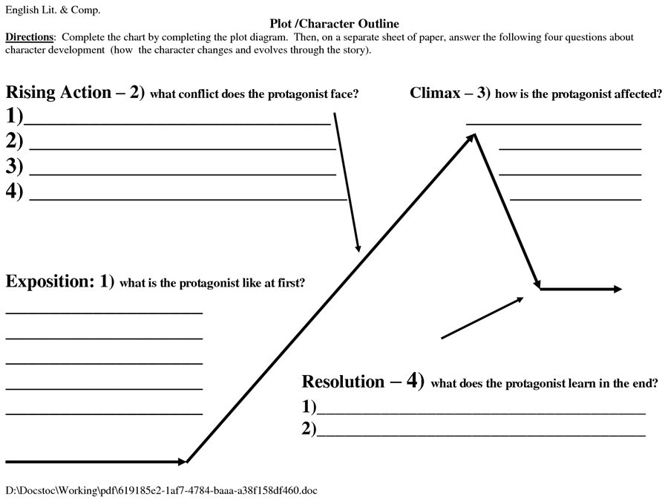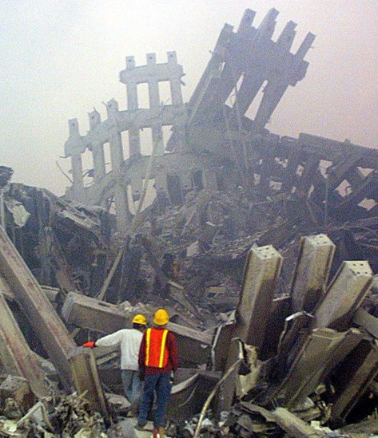

Shown below is the typical flow of a movie, Starting at the Exposition, moving to the Rising Action and Climax, and ending with a Resolution. Fill out the following sheet to show the basic structure of the 9-11 movie.

